ADS SEM QN -1 :
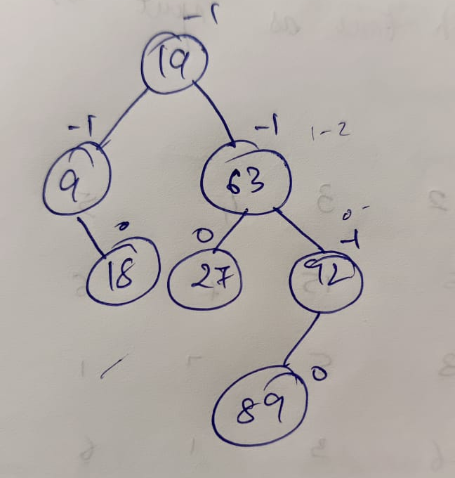
1.
2. Pseudocode to find the largest node in a Binary Search Tree (BST)
Concept: In a BST, the largest node is the rightmost node.
function findLargestNode(root):
if root is NULL:
return NULL
while root.right is not NULL:
root = root.right
return root.data
3.Properties of an m-way Tree
An m-way tree is a generalization of a binary tree where:
- Each node has at most m children
- It can have m-1 keys
- Keys are sorted in ascending order
- Pointers between keys refer to children whose values fall in between those keys
- Efficient for implementing B-Trees and databases
4. How many spanning trees are possible for the given graph
Given graph has 4 vertices and is fully connected (complete graph, K4K_4K4​).
Formula for number of spanning trees in a complete graph:
So, T=4(4−2)=42=16T = 4^{(4-2)} = 4^2 = 16T=4(4−2)=42=16
5. Time Complexity of Depth First Search (DFS)
DFS Time Complexity:
- O(V + E)

6. Heapify the given list using Min Heap
Input: 23, 56, 2, 31, 90, 43, 1, 29
We insert each into a min heap and maintain heap order (smallest on top):
Final Min Heap Tree (in array):
1, 23, 2, 31, 90, 43, 56, 29
8. Pseudocode of Tree Vertex Splitting
Concept: Split a high-degree node into two nodes to reduce degree.
function splitVertex(v):
create new node v'
move some children of v to v'
connect v and v' with an edge
10. Sort the word “MANAGEMENT” using Merge Sort
Word: M, A, N, A, G, E, M, E, N, T
Merge Sort Steps (conceptually):
- Divide until single letters
- Merge in sorted order
- Final sorted result: A, A, E, E, G, M, M, N, N, T

🌲 Forest (in Data Structures)
A forest is a collection of disjoint trees. That means it's a group of trees, where no node is shared between the trees.

🔹 Formal Definition:
A forest is a set of n ≥ 0 disjoint trees.

🔸 Example:
Consider this forest with 3 trees:
Tree 1: Tree 2: Tree 3:
A X M
/ \ \ / \
B C Y N O
In this forest:
- Tree 1 has root A
- Tree 2 has root X
- Tree 3 has root M
Each tree is independent and does not share nodes with the others.

🔁 Interesting Fact:
- If you remove the root of a tree, the remaining structure becomes a forest.
- A forest can be converted to a binary tree using left-child right-sibling representation.

pseudocode to find the smallest element in a Binary Search Tree (BST):
FUNCTION FindMin(Node):
IF Node IS NULL:
RETURN "Tree is empty"

WHILE Node.left IS NOT NULL:
Node = Node.left

RETURN Node.value
three cases to delete a node in a binary search tree.
 | Children Count | Action
 | 0 | Delete the node
2 | 1 | Replace with the single child
3 | 2 | Replace with inorder successor/predecessor
✅ Applications of Binary Search Tree (BST):
- Efficient Searching and Insertion:
  - BST supports fast search, insert, and delete operations with average time complexity of O(log n).
- Symbol Tables in Compilers:
  - Used to store and manage identifiers, variables, and keywords for quick access.
- Database Indexing:
  - Helps maintain sorted data and allows quick range queries and record lookups.
- Autocomplete and Spell Checkers:
  - Words are stored in BSTs to quickly find matches or suggestions.
- Network Routing Algorithms:
  - BSTs manage routing tables for efficient path lookup in network systems.
🟩 Self-Balancing Trees:
- ✅ AVL Tree
- ✅ Red-Black Tree
- ✅ B-Tree
✅ Properties of Red-Black Tree:
- Node Color:
Every node is either red or black.
- Root Property:
The root node is always black.
- Red Property (No two reds in a row):
A red node cannot have a red child (no two consecutive red nodes).
- Black Height Property:
Every path from a node to its descendant null nodes has the same number of black nodes.
- Leaf Property:
All null (NIL) leaves are considered black.
✅ Heap – Definition:
A Heap is a special tree-based data structure that satisfies the heap property:
- In a Max Heap, the parent node is always greater than or equal to its child nodes.
- In a Min Heap, the parent node is always less than or equal to its child nodes.

What is Hashing?
Hashing is a technique to convert data (like a name or number) into a fixed-size value called a hash.
Uses of Hashing:
- Dictionary / Map (e.g., Python's dict, Java's HashMap)
- Database indexing
- Password storage (using cryptographic hashes)
- Caches (like in web browsers)
❓ Why does Collision happen in Hashing?
A collision happens when two different keys get mapped to the same index by the hash function.

🔍 Why? Because:
- Limited storage (fixed size table):
The number of possible inputs (keys) is usually much larger than the number of available slots (buckets).
Example:
Hash table has 10 slots (0 to 9),
but you might input 1000 different keys — so some will share slots.
- Hash Function limits:
Even a good hash function can't guarantee unique outputs for all possible inputs unless your table is as big as the input space (which is impractical).
In hashing, when a collision occurs, probing helps us find another empty slot in the hash table to store the data.

1️⃣ Linear Probing
📌 Idea:
If a slot is full, check the next slot, then the next, and so on — one by one.
📐 Formula:
new_index = (hash(key) + i) % table_size
Where i = 0, 1, 2, 3, ...
✅ Example:
- Hash function: key % 10
- Key = 25 → 25 % 10 = 5 → slot 5
- Slot 5 is full → try slot 6, then 7, then 8...

2️⃣ Quadratic Probing
📌 Idea:
Instead of checking next slots one by one, check slots using squares (i²) for wider spacing.
📐 Formula:
new_index = (hash(key) + i²) % table_size
Where i = 0, 1, 2, 3, ...
✅ Example:
- Hash function: key % 10
- Key = 25 → 25 % 10 = 5 → slot 5
- Slot 5 is full → try slot (5 + 1²) = 6, (5 + 2²) = 9, (5 + 3²) = 14 % 10 = 4, ...

🔁 Difference Summary Table:
Feature | Linear Probing | Quadratic Probing
Slot check pattern | 1, 2, 3, ... | 1², 2², 3², ...
Clustering | High (Primary clustering) | Low (Reduces clustering)
Simpler to implement | Yes | Slightly more complex

